**Data Flow Diagram**

**Context diagram for Yatra**

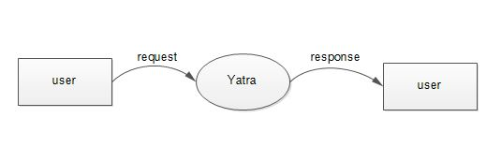

**First level DFD for Yatra - Admin**

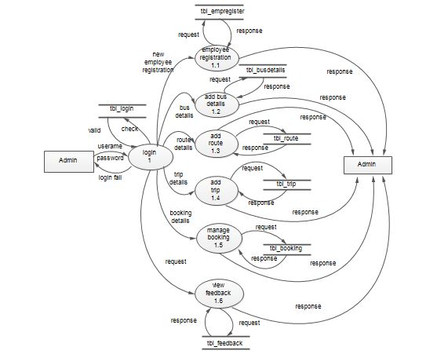

**First Level DFD for Yatra – Employee**

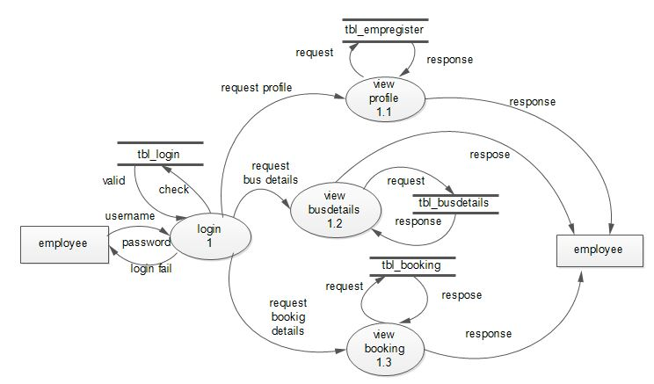

**First level DFD for Yatra - Customer**

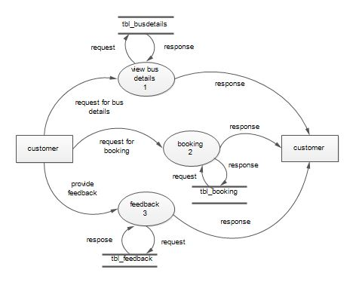

**Second level DFD for Yatra -- Customer-Booking**

